Registered Manager Manchester/Trafford
Ordinary Lifestyles currently provides support to 35 individuals with learning disabilities across Manchester and Trafford. All our supported individuals live in small-scale settings, either on their own or with one or two co-tenants, enabling us to provide services that are truly designed around the individuals’ unique needs. We employ around 90 staff and are run on a not-for-profit basis.

Main Duties & Responsibilities:

Ordinary Lifestyles is recruiting for a professional, motivated and values driven individual, who we can support through the process of becoming a Registered Manager. The successful candidate must have the necessary experience within the Health and Social \Care sector and have relevant knowledge of the CQC and meeting their Fundamental Standards.
Our Values:

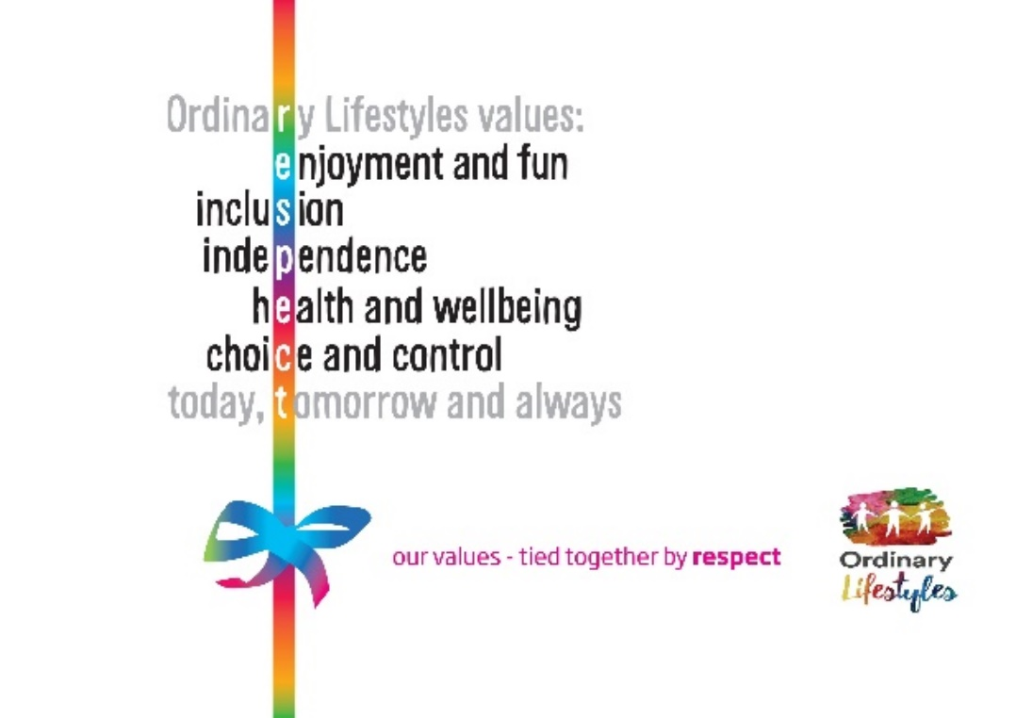

We are currently rated as GOOD with the CQC and hold an Investors in People Gold Award.

At Ordinary Lifestyles you’ll have the chance to make a difference to the lives of the people we support.

It’s a varied and rewarding role with opportunities to develop high quality services.

You will be part of a small management team reporting directly to the CEO. Our Registered Managers are responsible for providing strong and effective leadership to their teams. You will ensure that our services are delivered effectively, in line with our values and regulatory requirements in order to meet the needs of the people we support.

Good written and verbal communication skills are essential along with strong organisational skills and the ability to prioritise and manage a busy workload. Flexibility to the needs of the service is essential.

You will play a key role in developing Ordinary Lifestyles by contributing to and working towards the targets identified in our Strategic Action Plan.

Interested, and want to make a real difference? Then we would love to hear from you!

*Interviews to be based at our Head Office in Failsworth*

All successful candidates will be required to complete a full paid induction which will take place in Failsworth.

Job Types: Permanent, Part-time, Full-time
Starting salary: £ 44,428 per year (pro rata if part time)

For an application pack or more information please visit our website www.ordinary-lifestyles.org.uk or contact: admin@ordinary-lifestyles.org.uk

The closing date for applications is Monday 8th April 2024.

.

