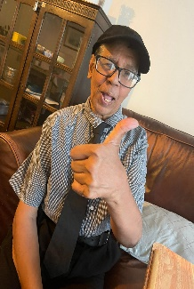

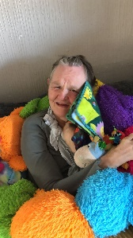

**Find out why there are BIG smiles and BIG thumbs up all around for**

**Individual and Family**

**Quality Improvement Questionnaire Results 2022**

**Summary**

In July 2022 the questionnaire below was circulated to the individuals we support, their families and other significant people involved in their care and support.

Our Operations Coordinator was available to support people to complete the questionnaires to try and ensure people did not feel influenced or pressured and could give open feedback on the service they receive from Ordinary Lifestyles. Gillian supported 20 people to complete questionnaires.

In total 46 questionnaires were sent out, 27 questionnaires were returned, the results and comments are collated on the following pages. The results received are incredibly positive with 100% agreeing with all 5 statements. This year there was a change to the format with only 3 responses, in previous years we had 5 responses (Strongly disagree, disagree, neutral, agree and strongly agree). It is also worth noting that the response rate is not as good as previous years.

**I am happy with the service Ordinary Lifestyles provides to me/my family member**

|  |  |  |
| --- | --- | --- |
| **1** | **2** | **3** |
|   **Disagree** | **Neutral** | Agree** |

**The Support Workers who work with me/my family member are well-matched and understand my/their needs**

|  |  |  |
| --- | --- | --- |
| **1** | **2** | **3** |
|   **Disagree** | **Neutral** | Agree** |

**Ordinary Lifestyles supports me/family member to have full choice and control in my/their life**

|  |  |  |
| --- | --- | --- |
| **1** | **2** | **3** |
|   **Disagree** | **Neutral** | Agree** |

**The Support Workers have a good understanding of me/my family member’s health and wellbeing**

|  |  |  |
| --- | --- | --- |
| **1** | **2** | **3** |
|   **Disagree** | **Neutral** | Agree** |

**Ordinary Lifestyles is well led and well managed**

|  |  |  |
| --- | --- | --- |
| **1** | **2** | **3** |
|   **Disagree** | **Neutral** | Agree** |

**What does Ordinary Lifestyles do well?**

**You said …**

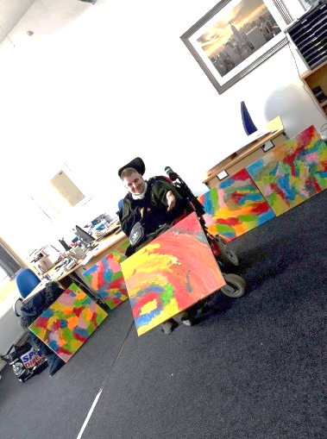“Every time I have been the office you all have been working and you stop just to talk to me, each and every one stop to have a laugh with me. It makes me feel very good. I think in my head when I come in feeling uptight that you think I’m a nuisance and stopping you from working. But that’s how my crazy mind works and I know you are not thinking of me that way because you stop and talk to me all the time!”

“They do the job well; very nice company and the company keeps me nice”

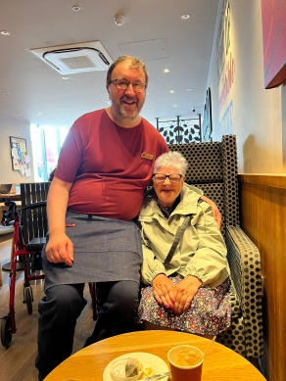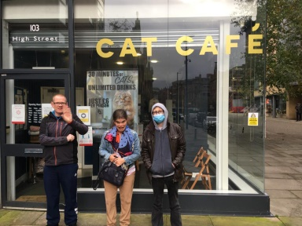“Look after you, stop you feeling anxious and gets you nice presents at Christmas”

“Good – I like going out to café”

“Give things to do, keep me safe”

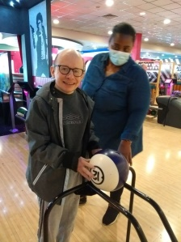“Being good”

“Bowling, meeting with friends”

“Taking me out”

“Helping us, very good”

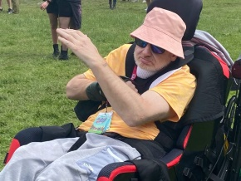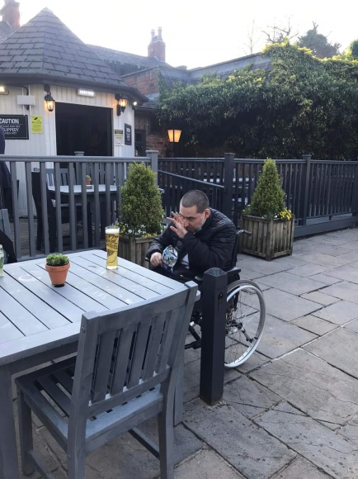“Look after people, see if they’re alright, have a nice time, take am Charity shops, have a good time and laughing and very good friends and come to the house and see them”

“Good discos and holidays”

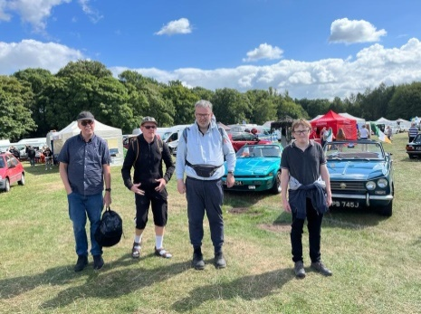“Rota’s, work with me and take me out”

“They doing a great job, they take me to Whetherspoons, I like the disco”

“Ok, make me happy, Christine makes me happy”

“Good disco – help with showers, make sure everything is ok and tidy up and we all help”

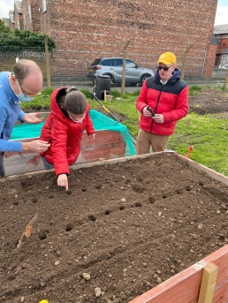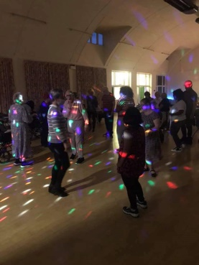“Allotment, Disco”

“Bowling and allotment”

“Everything”

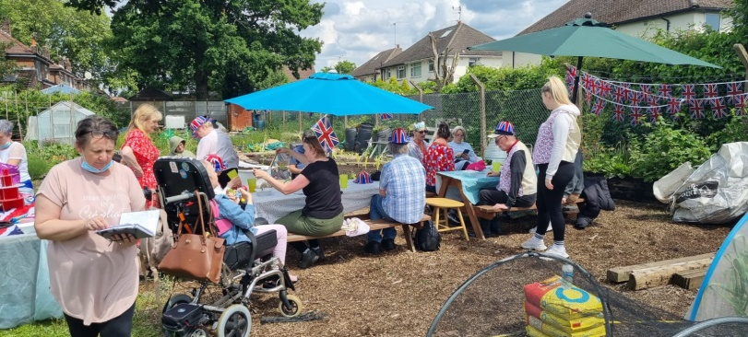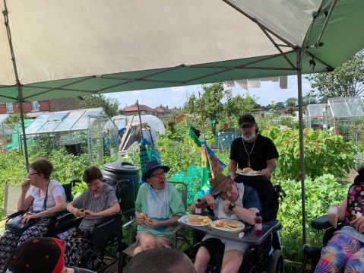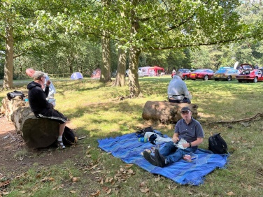“Ordinary Lifestyles have a good selection of staff and are very friendly. Make people happy when we have things like Jubilee and other activities all the people are there with their support and other families which is good and there is a new venue Summer in the Park, we should go to the park have BBQ, games etc”

“Very caring about the individual and the staff make things fun”

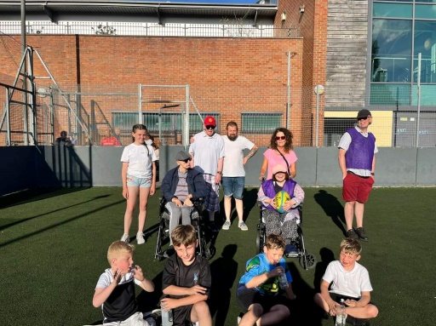“Focus on the person, work hard to provide a full life”

“Everything – they are extremely helpful with

every aspect of life and understand all needs”

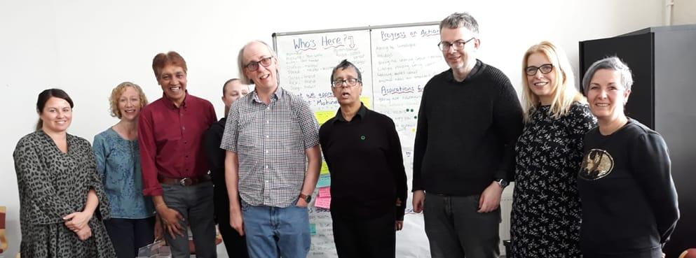“Good communication between staff and family, Regular meetings are now back in place after covid, removal of mask wearing of staff, that will have a positive impact on service users, holidays and outings are getting back to normal”

“They are always there”

“Good leadership with happy environment promoted. Has supported well to move into post lockdown activity mode! Planned, organised (and supported) holiday that was much needed. Good recruitment of new staff with good blend of youth and experience. Supported well throughout the anxieties of covid testing, changes to routine and particularly with varied levels of client support needs, anxieties etc. Excellent at looking for and supporting clients to overcome barriers and extend their comfort zone. Special mention and thanks to one member of staff who acquired information and knowledge about a specific autism type and uses this to personalise client approach and offer very positive support experiences”

**Suggestions for improvement:**

|  |  |
| --- | --- |
| **You said …**  “Ok as it is” “No” “None” “Nothing” “Everything is alright”  “I would like to do more work like gardening and making orange drinks”  “Do more activities like Summer in the Park”  “I want more exciting things to do but my mind doesn’t know what, it’s a b@****d my mind”  “More holidays or try abroad as a group or Skegness”  “When I get a letter from the office I get excited, open it, read it to see what it says and it’s not what I really wanted because it’s not very exciting”  “Want to see Rebecca’s dog”    “The traffic outside my house”  Study says EU moving too slowly on noise pollution – EURACTIV.com  “Could do with more staff”    “Let service users do interviewing”  “More awareness and staff support with specifics within autism – newer/ less experienced staff obviously find it more challenging to find methods to reduce stress whilst enabling/ promoting activities. (Easy for autism traits to be misunderstood as rudeness etc) Enable staff to engage more successfully with clients who are reluctant to accept support and/or work on the assumption that the client is capable of more than they actually are. Obviously an issue and can clash with the overall aim of self-advocacy but also easily leads to underachievement or failure” | **Our response …**  **12 questionnaires indicated there was nothing to improve.**  **It seems from your answers to what we do well people are enjoying the disco, the allotment and bowling. These activities take place regularly and if you want jobs at the disco please let us know!**  **We have been working on restarting the cooking group, and also looking at a new weekly group which will hopefully incorporate monthly arts and craft, sing and sign, Peoples forum and much more.**  **This is all part of our Strategic Action Plan**  cid:ec54cece-4ba8-4c34-9a00-54341c1524fa  **We have discussed this in the Peoples Forum meeting and plan to have a group holiday next year.**  cid:d1e0c94e-33e0-4e4e-8aa2-64058a6b399f  **Noted – we will try and send more exciting letters in future.**  **Woof woof! Me too. We hope you can come to our first Health and Wellbeing even on the 31st August a Dog Walk and Talk!**  **Hopefully Simba will make an appearance there**    **We understand that this can be annoying if you live on a busy road. Some people find it helpful to use mindfulness activities such as calming music, colouring or jigsaws to take their mind off things.**  NEW Mindful Colouring Pages | Amazing Animals! | Teach Starter  **Agreed! We have just had some new leaflets printed to try and help with targeted recruitment in certain areas, if you would like to deliver some please let us know.**  **We will also be attending a recruitment event on the 30th September at the Etihad. If you would like to help with this please get in touch with Kathy.**  cid:392ab5cf-fb5a-4a16-93c8-5ed54ccde0a2**We have had positive feedback about our recent Autism training provided by Jane Forrest (Lead Autism Trainer for Trafford) which involves experts by experience (from United Response). We encourage staff to reflect on any training and consider how it can be best used with the individuals they support. We also discuss support of individuals during staff job consultations and use these opportunities to try to increase staff understanding of why individuals may behave in certain ways.**  **When individuals are reluctant to engage with support we try to work with families and try different approaches. If we are not making progress we need to explore to see if better provision is available for this person.** |

**THANK YOU to everyone who completed our questionnaire!**