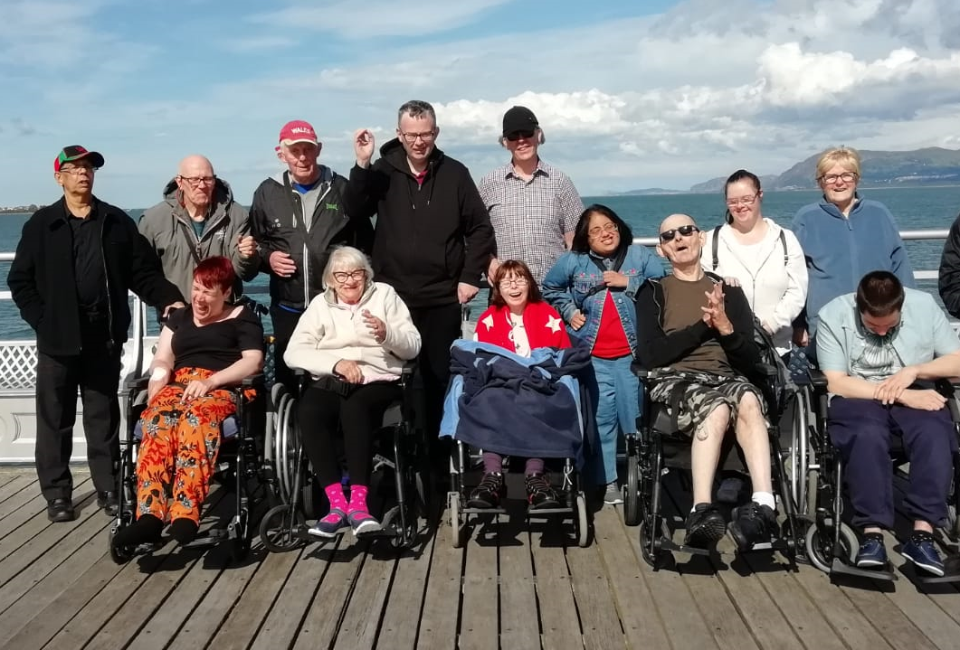

We are recruiting!

Support Worker Vacancies
Full and part time as well as maternity cover
(including evenings, weekends and sleep-ins)

Blackley, Wythenshawe, Timperley, Harpurhey and Central Manchester areas
Rotas are based over 7 days a week

Driving Licence Preferred

Waking Night Support Worker Vacancy
15 hrs per week in Clayton

Start rate £9.50 p/hour/Waking Nights £10.70 p/hour
Full training given
For an application form please call: 01612020050 or
email: admin@ordinary-lifestyles.org.uk

